Bridge Civics

Grade 7 Social Studies

Week 5: April 27- May 1

Your Week at a Glance

Daily Schedule (Suggested)

Day 1:

International Organizations Current Event- The World Health Organization (WHO) You may use the one provided or pick your own.

Day 2:

International Organizations Current Event- The United Nations You may use the one provided or pick your own.

Day 3

International Organizations Current Event- Red Cross

You may use the one provided or pick your own.

Day 4

Finish all three International Organizations Current Events

Day 5:

Quizziz- International Organizations

Additional Support:

Brain Pop: You can create a FREE family access account.

Videos: -United Nations -League of Nations

Name___________________________________________________________________

CURRENT EVENT ASSIGNMENT

The purpose of this assignment is to (1) increase your ability to research current issues in social studies, (2) to increase your understanding of the role of international organizations with regard to foreign affairs, and (3) to be able to critically evaluate news articles regarding contemporary issues.

You are to include the following criteria in your assignment:

- Proper Titles – 4pts.

  - Your full name in the top right corner.

  - What is the name of the article? Exact wording in bold-type, centered on the page.

- Article Source – 6pts.

  - Using the MLA style of citation, where did you get the article? See attached sample.

- Summary – 10pts.

  - In YOUR words, summarize the content of the article. Include the who, what, where, why and when.

  - Four (4) sentence minimum.

- Analysis – 10pts.

  - What are the positions held by the people mentioned in the article?

  - How do you feel about this event/issue?

  - How does or how could this event affect you?

  - Can you detect author bias within the article? Explain(use quotes)

  - Four (4) sentence minimum using the examples above as a guide.

- Impact – 10pts.

  - Why should the American people care about this event?

  - Four (4) sentence minimum.

Citing Websites with one author:

Place the author’s name in reverse order, the last name first, followed by a comma, and then the first name followed by a period. The title of the web page or article is placed in quotation marks, with a period before the end quotation. The title of the website is written in italics followed by a comma. If the name of the publisher differs from the name of the website, include it after the title. Immediately following the publisher is the date that the page or article was published, or posted. Finally, end with the URL, permalink, or DOI.

Example on the next page

Author’s Last name, First name. “Title of the Article or Individual Page.” Title of the Website, Name of the Publisher, Date of Publication in Day Month Year format, URL.

McNary, Dave. “Keanu Reeves, Alex Winter Returning for ‘Bill and Ted Face the Music.’” Variety, Penske Media Corporation, 8 May 2018, variety.com/2018/film/news/bill-and-ted-3-keanu-reeves-alex-winter-1202802946/.
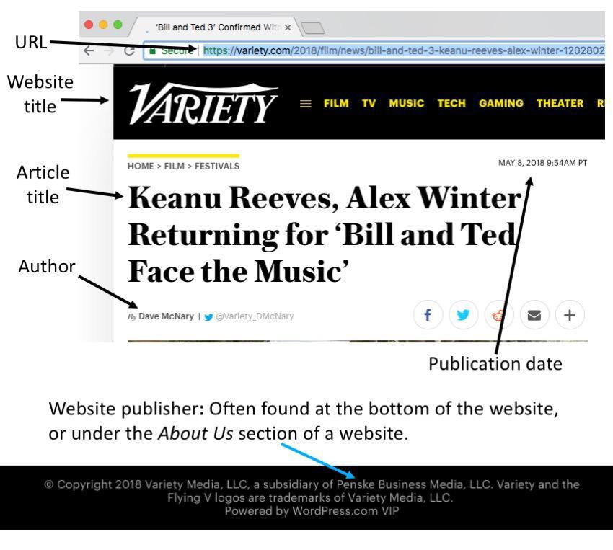

If no author is given, begin with the Title of the article.

Name____________________________

Current Event- World Health Organization Directions:

1.Read the following article. Underline or highlight key points as you read such as who is involved, what it’s about, where it happened, why it happened, when it happened, and why it’s important to know.

- Complete the Current Events International Organizations assignment either on Microsoft Teams or your own paper.

Trump considering suspending funding to WHO
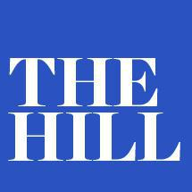
BY MORGAN CHALFANT - 04/07/20 06:49 PM EDT

https://thehill.com/homenews/administration/491671-trump-considering-suspending-funding-to-who

President Trump said Tuesday that he would consider placing a hold on funding for the World Health Organization (WHO),

expressing grievances with its handling of the novel coronavirus.

“They missed the call. They could have called it months earlier. They would have known, and they should have known, and they probably did know,” Trump told reporters at a White House press briefing, suggesting the WHO failed to sufficiently warn the global community about the virus.

“We’re going to be looking into that very carefully, and we’re going to put a hold on money spent to the WHO,” Trump continued. “We’re going to put a very powerful hold on it, and we’re going to see. It’s a great thing if it works, but when they call every shot wrong, that’s not good.”

Pressed later by a reporter on whether it was a good idea to put a hold on funding during a global pandemic, the president clarified that he was considering suspending funding to the WHO.

“I’m not going to say I’m going to do it,” Trump said. “We will look at ending funding.”

The United States is the largest contributor to the WHO’s budget. The president’s fiscal 2021 budget request proposed slashing funding to the WHO, a body of the United Nations responsible for international public health, from $122 million to about $58 million.

The president said the WHO seemed to be “very biased towards China” and accused the organization of disagreeing with his travel restriction on flights coming in from China. He suggested the organization was blind to the extent of the outbreak in Wuhan, the capital of China's Hubei province, where the virus originated.

The WHO said in early February that widespread travel bans that interfere with international travel and trade were not necessary to prevent the spread of COVID-19, days after the Trump administration announced it would restrict travel coming into the U.S. from China. It did not take particular issue with the president's travel restriction.

“They actually criticized and disagreed with my travel ban at the time I did it, and they were wrong. They’ve been wrong about a lot of things. They had a lot of information early, and they didn’t — they seemed to be very China-centric. We have to look into it,” Trump told reporters.

When a reporter asked Anthony Fauci, head of the National Institute of Allergy and Infectious Diseases, to answer a question on the WHO, Trump interjected before he answered, saying Fauci “respects the WHO, and I think that’s good.”

“But they did give us some pretty bad play-calling,” Trump said.

The remarks, expanding on a critical tweet he sent earlier Tuesday, come amid growing criticism among conservatives of the WHO’s handling of the coronavirus outbreak. Some have accused the organization of leaving other nations unprepared for the virus.

Sen. Martha McSally (R-Ariz.) last week called on WHO Director-General Tedros Adhanom Ghebreyesus to resign, after reports emerged that the U.S. intelligence community had concluded China underreported its count of coronavirus cases. McSally accused the WHO of helping China conceal the extent of the outbreak.

Trump has faced criticism for at first downplaying the threat from the coronavirus, and his administration has been scrutinized for early delays in testing that hampered the overall response. Trump has often pointed to his early action restricting travel from China as a sign his administration was quick to confront the outbreak.

Ezekiel Emanuel, a special adviser to the director general of the WHO, was critical of Trump’s remarks on the coronavirus at the end of February, saying he found much of what Trump said at his first press briefing on the domestic virus outbreak to be “incoherent.”

Name____________________________

Current Event- United Nations

Directions:

1.Read the following article. Underline or highlight key points as you read such as who is involved, what it’s about, where it happened, why it happened, when it happened, and why it’s important to know.

- Complete the Current Events International Organizations assignment either on Microsoft Teams or your own paper.

Ban wildlife markets to avert pandemics, says UN biodiversity chief

THE GUARDIAN
By Patrick Greenfield

Mon 6 Apr 2020 00.00 EDTLast modified on Mon 6 Apr 2020

https://www.theguardian.com/world/2020/apr/06/ban-live-animal-markets-pandemics-un-biodiversity-chief-age-of-extinction
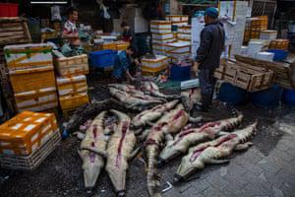

Crocodiles on display for buyers at Huangsha seafood market in Guangzhou, Guandong province, China. Photograph: Aleksandar Plavevski/EPA-EFE

The United Nations’ biodiversity chief has called for a global ban on wildlife markets – such as the one in Wuhan, China, believed to be the starting point of the coronavirus outbreak – to prevent future pandemics.

Elizabeth Maruma Mrema, the acting executive secretary of the UN Convention on Biological Diversity, said countries should move to prevent future pandemics by banning “wet markets” that sell live and dead animals for human consumption, but cautioned against unintended consequences.

China has issued a temporary ban on wildlife markets where animals such as civets, live wolf pups and pangolins are kept alive in small cages while on sale, often in filthy

conditions where they incubate diseases that can then spill into human populations.
Many scientists have urged Beijing to make the ban permanent.

Using the examples of Ebola in west-central Africa and the Nipah virus in east Asia, Mrema said there were clear links between the destruction of nature and new human illnesses, but cautioned against a reactionary approach to the ongoing Covid-19 pandemic.

“The message we are getting is if we don’t take care of nature, it will take care of us,” she told the Guardian.

“It would be good to ban the live animal markets as China has done and some countries. But we should also remember you have communities, particularly from low-income rural areas, particularly in Africa, which are dependent on wild animals to sustain the livelihoods of millions of people.

“So unless we get alternatives for these communities, there might be a danger of opening up illegal trade in wild animals which currently is already leading us to the brink of extinction for some species.

“We need to look at how we balance that and really close the hole of illegal trade in the future.”

As the coronavirus has spread around the world, there has been increased focus on how humanity’s destruction of nature creates conditions for new zoonotic illness to spread.

Jinfeng Zhou, secretary general of the China Biodiversity Conservation and Green Development Foundation, called on authorities to make the ban on wildlife markets permanent, warning diseases such as Covid-19 would appear again.

“I agree there should be a global ban on wet markets, which will help a lot on wildlife conservation and protection of ourselves from improper contacts with wildlife,” Zhou said. “More than 70% of human diseases are from wildlife and many species are endangered by eating them.”

Mrema said she was optimistic that the world would take the consequences of the destruction of the natural world more seriously in the wake of the Covid-19 outbreak when countries returned to negotiate the post-2020 framework for biodiversity, billed as the Paris agreement for nature.

“Preserving intact ecosystems and biodiversity will help us reduce the prevalence of some of these diseases. So the way we farm, the way we use the soils, the way we protect coastal ecosystems and the way we treat our forests will either wreck the future or help us live longer,” she said.

“We know in the late 1990s in Malaysia with the outbreak of Nipah virus, it is believed that the virus was a result of forest fires, deforestation and drought which had caused fruit bats, the natural carriers of the virus, to move from the forests into the peat farms. It infected the farmers, which infected other humans and that led to the spread of disease.

“Biodiversity loss is becoming a big driver in the emergence of some of these viruses. Large-scale deforestation, habitat degradation and fragmentation, agriculture intensification, our food system, trade in species and plants, anthropogenic climate change – all these are drivers of biodiversity loss and also drivers of new diseases. Two thirds of emerging infections and diseases now come from wildlife.”

In February, delegates from more than 140 countries met in Rome to respond for the first time to a draft 20-point agreement to halt and reverse biodiversity loss, including proposals to protect almost a third of the world’s oceans and land and reduce pollution from plastic waste and excess nutrients by 50%.

A major summit to sign the agreement in October was scheduled in the Chinese city of Kunming but has been postponed because of the coronavirus outbreak.

Name____________________________

Current Event-Red Cross

Directions:

1.Read the following article. Underline or highlight key points as you read such as who is involved, what it’s about, where it happened, why it happened, when it happened, and why it’s important to know.

- Complete the Current Events International Organizations assignment either on Microsoft Teams or your own paper.

American Red Cross faces 'severe blood shortage' as

cancellations increase due to coronavirus Nearly 2,700 Red Cross blood drives have been cancelled in the U.S.

By Mychael Schnell

March 17, 2020, 4:02 PM

https://abcnews.go.com/Politics/american-red-cross-faces-severe-blood-shortage-cancelations/story?id=69642130

The American Red Cross said they're now facing a "severe blood shortage," as blood drives across the country continue to be cancelled as concerns over the novel coronavirus pandemic grow.

"Right now, the Red Cross is distributing blood donations faster than they are coming in," Paul Sullivan, senior vice president of the American Red Cross, told ABC News.

"As concerns about COVID-19 grow and more blood drive cancellations come, the Red Cross and other blood collection organizations as well as hospitals across the country have heightened concerns about our ability to meet patient needs," Sullivan continued. "That’s why we are asking healthy individuals to roll-up a sleeve and give blood now."

As of Tuesday morning, nearly 2,700 Red Cross blood drives in the U.S. have been cancelled, resulting in approximately 86,000 fewer blood donations, according to a statement from the organization.

These numbers are a dramatic increase from what was reported just last week. On Friday, Red Cross told ABC News that 600 blood drives had been cancelled -- resulting in only about 18,000 fewer blood donations. The impact has increased almost five times -- a product of both fewer donors and blood drives.

"Over the last week we’ve seen both fewer donors come to our blood drives, and then over the coming weeks we’ve seen a number of organizations cancel their blood drives," Sullivan said.

Sullivan said the need for blood products hasn't changed amid the crisis, and "we have seen our supply decline."

"It’s concerning and that’s why we’re making the ask now of people to come out and support our blood drives and we’ll work hard to make sure they remain safe, but we do need them because we need to help patients at hospitals," he said.

Some hospitals are already seeing the effects of this blood shortage. In the Red Cross statement on Tuesday, a Michigan doctor spoke about the consequences he is seeing in his hospital.

“I am looking at the refrigerator that contains only one day’s supply of blood for the hospital," Dr. Robertson Davenport, director of transfusion medicine at Michigan Medicine in Ann Arbor, said in the statement. "The hospital is full. There are patients who need blood and cannot wait."

In their statement, Red Cross wrote a blood shortage can impact patients who need surgery, victims of car accidents or individuals who are suffering from cancer. Sullivan explained that the organization is working hard to avoid a situation where doctors would have to decide how best to use the blood they have.

"Right now, no one receives a blood transfusion who absolutely doesn’t need it," Sullivan said, adding that some "people need these transfusions, they’re literally life-sustaining, life-saving."

He continued, "So we are again working hard to make sure we don’t put doctors in that position of having to make very difficult choices about how to utilize blood products to help save people’s lives."

Red Cross is anticipating more drives to be cancelled in the near future. Because of this, they continued to stress the importance of donating blood, and encouraging healthy individuals to become donors.

"As a nation, this is a time where we must take care of one another including those most vulnerable among us in hospitals," Gail McGovern, president and CEO of Red Cross, said in the statement. "One of the most important things people can do right now during this public health emergency is to give blood. If you are healthy and feeling well, please make an appointment to donate as soon as possible."

The organization explained that while they understand people may be "hesitant" to visit a blood drive, they are implementing several precautions to ensure that donors and staff remain healthy.

The precautions include taking the temperature of all individuals before they enter a blood drive location, providing hand sanitizer throughout the donation process, spacing beds according to social distancing standards and disinfecting all surfaces and equipment.

"We understand why people may be hesitant to come out for a blood drive but want to reassure the public that blood donation is a safe process, and that we have put additional precautions in place at our blood drives to protect the health and safety of our donors and staff," McGovern said in the statement.

Quizziz- International Organizations

Directions: When participating in this activity use your first name, last initial.

International Organizations Code is available from your teacher to play online or you can complete the paper version. Please check their website or contact them. Play for an “A”!

